The Friends Bishops Park
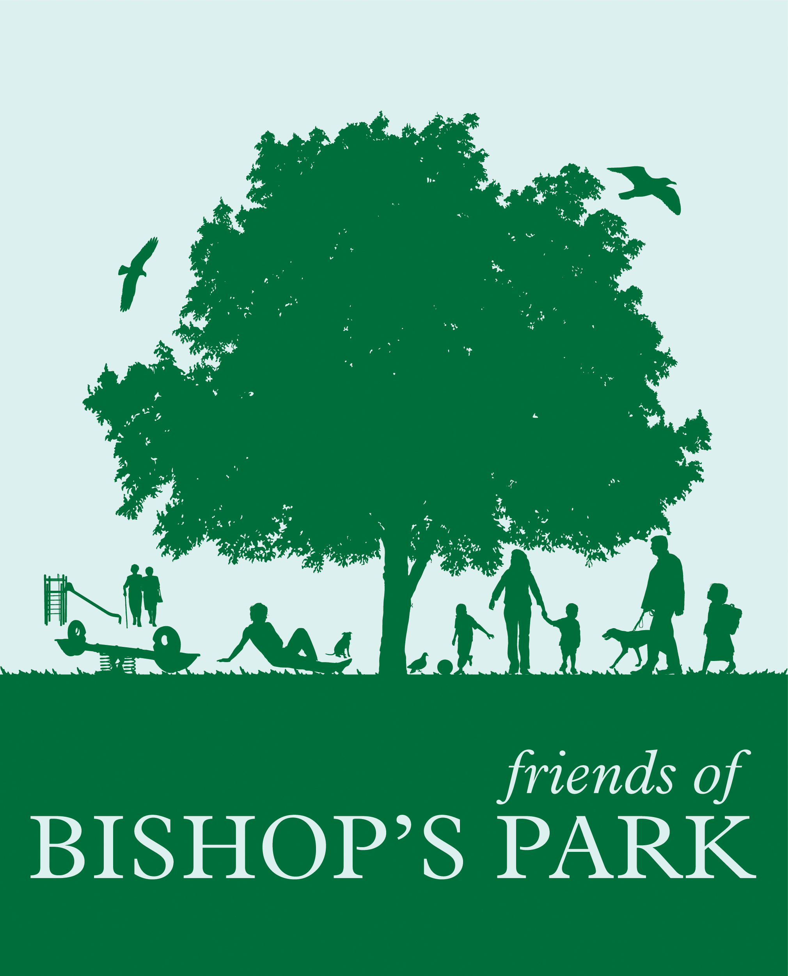

By email
Planning Division
Hammersmith Town Hall Extension
King Street, London W6 9JU

Attention: Sian Brown, Acting Principal Planning Officer South Area
8th January 2018

Fulham FC Application for the construction of a new riverside stand and partial reconfigurations of the Putney and Hammersmith stands. 2017/04662/FUL

OBJECTION

1. While this application is in some ways similar to that given permission in 2013 we say it must be considered afresh and the old permission NOT treated as a precedent. The planning system has moved on and there is greater appreciation by many of the public of the value and importance of open space, particularly parks and the river. It should not be “shaved away” to provide financial benefit to a neighbouring freeholder.

2. This application will seek again to about double the capacity of the riverside stand, but with a totally different structure. It will however be considerably higher than the existing stand, which we all know and some of us even like.

3. The design and layout of the ground needs to ensure that all spectators can leave within eight minutes. Ever since the ground was first used all entrance into the ground and exit from it has been through the Stevenage Road frontage. Even with the increased capacity of the river side stand, this could still be achieved if appropriate alterations were made to the stand at the ends of the ground, the so-called Putney and Hammersmith stands. However the applicant has chosen not to do that, rather it has assumed, wrongly we say, that it can take over the parks at each end, and use them as access ways for entrance and exit.

4. However we are not told what the park will look like on completion. We fear that extensive areas of the park will need to be tarmacked to provide hard surface for those waiting to enter the ground. And their departure will need surfaced paths inevitably based on “desired” routes. What will this look like? This application should not be considered until these questions are answered.

5. We do not think that permission should be granted for new access routes into the ground which would either lead to additional damage to the grassed areas of either park or require any additional tarmacking of either park. If, nevertheless, permission were granted the Club would effectively be taking over areas of the park to provide entrance into and exit from their ground, they should pay for this use, and not just a one-off payment, but payments in perpetuity.

6. At least this application is more upfront. The previous planning application had little on the construction process. This we are now told will require the closure for two or three years of a section of Bishops Park for it to be used as a construction site. An area of the river will be needed for the construction of pontoons etc in the river. Albeit temporary, these will be a significant adverse impact on the parks at both ends of the site, on the riverside path, and the surrounding predominantly residential area. The loss will be considerable and should not be permitted.

7. We say the construction of such a large building is totally inappropriate in a Conservation Area. It is out of scale with the other buildings of the stadium and with the surrounding townscape, and in no way reflects the area’s character.

8. The major difference is the use of the space under and behind the seating. The permission they have allows retail and commercial space but with a floor area of 7,000 sqm – they now intend to make greater use of this space increasing it to 13,600 sqm. What uses they will put this area is not clear. There has been talk of a riverside pub, a new “River Café”, and holding conferences attended by 1,000 people. Indeed at the Friends of Bishops Park AGM, the Club’s representative asked “what would you like?” But the essential challenge is that the Club wants to make greater use of the site and introduce revenue streams on non-match days and other than from football. West London is not short of pubs, restaurants, coffee shops. There is no evidence of a need for more. There is a view that the quiet, peaceful character of the “alphabet streets” came about because there were no pubs or restaurants: we say there is no identified need for further facilities and the existing much valued quiet ambiance would be threatened.

9. But because the club’s intentions are vague and not quantified we say this is an incomplete application. We support the club’s continued use of the site for playing football but we oppose its partial conversion into an ill-defined and unwanted “events space”.

10. The new application will still require encroachment into the river of 11m. It may be suggested that part of the encroachment may benefit the local community with a riverside path. However it is worth remembering that in recent years a riverside path has been completed from the football ground to Hammersmith Bridge, and this forms part of a national trail, the Thames Path National Trail. This was done without encroachment into the river, each riparian owner provided part of their land for public use. Why should this application be allowed to disregard this widely accepted policy and practice for Fulham Football Club’s own financial benefit?

11. Further this application says that the riverside path will be closed on match days. We say the land on which the walkway is provided would then be a National Trail and therefore should be within the control of the local authority and the public’s right to use the path in perpetuity should be secured by a S106 or other legal agreement.

12. It will still be a cliff like structure overhanging the river which will block the wind and seriously threaten the use of the river for recreational and competitive sailing, and be a safety hazard. We note that the sailing clubs consider that the mass, positioning and design of the proposed development will stop or harm sailing activities, impede navigation and affect safety. If sailing does not take place in this area, it will move elsewhere, bringing conflict with other competitive and recreational use of the river, leading to adverse impact on it.

13. We are concerned about the proposed structure supporting the riverside path. If water is to flow through it, it will possibly be a safety hazard, but a debris trap for certain.

14. We say that the plan that there will be reeds and plant thriving under the riverside pathway is fanciful.

15. The application includes the construction of nine apartments. However these will not be for sale; they will be “serviced apartments” used by guests of the Club. We say that if this application were to be approved there should be conditions which would enforce this type of use.

16. Mitigation
Were the Council minded to grant approval there are clearly many aspects which will require and should receive mitigation measures. As yet these are not defined and should, we believe, be the subject of further consultation.

17. In view of the comments, concerns and objections outlined in the paragraphs above we say the Council should refuse this application.

Yours sincerely,

Amanda Lloyd-Harris
Chair Friends of Bishops Park
c/ 54 Langthorne Street,
London, SW6 6JY

